Emotion recognition by inclusion of age and gender parameters   using deep learning

A Synopsis Report Submitted by

Ashwamedh (4nm19cs031)

Aditya Murugan (4nm19cs010)

Akil Raif (4nm19cs014)

Adithya Holla k (4nm19cs007)

UNDER THE GUIDANCE OF

MR. MAHESH KINI

        Assistant Professor Gd-11

Department of Computer Science and Engineering

# in partial fulfilment of the requirements for the award of the Degree of

**Bachelor of Engineering in**

**Computer Science & Engineering**

from

# **Visvesvaraya Technological University, Belagavi**



DEPARTMENT OF COMPUTER SCIENCE AND ENGINEERING

# N.M.A.M. INSTITUTE OF TECHNOLOGY

(An Autonomous Institution under VTU, Belagavi) (AICTE approved, NBA Accredited, ISO 9001:2008 Certified) NITTE -574 110, Udupi District, KARNATAKA.



(ISO 9001:2015 Certified), Accredited with ‘A’ Grade by NAAC

   : 08258 - 281039 – 281263, Fax: 08258 – 281265

Department of Computer Science and Engineering

B.E. CSE Program Accredited by NBA, New Delhi from 1-7-2018 to 30-6-2021

DEPARTMENT OF COMPUTER SCIENCE AND ENGINEERING

CERTIFICATE

“QUORA CLONE” is a bonafide work carried out by Adithya Holla K(4NM19CS007), Arsh Imtiyaz Assadi(4NM19CS032) in partial fulfilment of the requirements for the award of Bachelor of Engineering Degree in Computer Science and Engineering prescribed by Visvesvaraya Technological University, Belagavi during the year 2022-2023.

It is certified that all corrections/suggestions indicated for Internal Assessment have been incorporated in the report.

The Mini project report has been approved as it satisfies the academic requirements in respect of the project work prescribed for the Bachelor of Engineering Degree.

Signature of Guide Signature of HOD

**ACKNOWLEDGEMENT**

We believe that our project will be complete only after we thank the people who have contributed to make this project successful.

First and foremost, we express our deep sense of gratitude and indebtedness to our guide **DR.ANISHA.P.RODRIGOUS**, Designation, Department of Computer Science and Engineering, for his inspiring guidance, constant encouragement, support and suggestions for improvement during the course of our project.

We sincerely thank **Dr. Jyothi Shetty**, Head of Department of Computer Science and Engineering, Nitte Mahalinga Adyantaya Memorial Institute of Technology, Nitte.

Our sincere thanks to our beloved principal, **Dr. Niranjan N. Chiplunkar** for giving us an opportunity to carry out our project work at our college and providing us with all the needed facilities.

We also thank all those who have supported us throughout the entire duration of our project.

Finally, we thank the staff members of the Department of Computer Science and Engineering and all our friends for their honest opinions and suggestions throughout the course of our project.

ARSH IMTIYAZ ASSADI (4NM19CS032)

ADITHYA HOLLA K(4NM19CS007)

**ABSTRACT**

Quora Clone App- Our app is typically a question-and-answer app where people have their own accounts and people can post the questions they have on the app.

The other people who use the same app can answer the questions they know. Sometimes it is difficult to find the whole of internet for certain information but there will be people who have enough knowledge and resources to give others that information, the platform enables such individuals to share their knowledge and also answer people’s questions.

The required data is stored and retrieved using firebase database. The app is coded in Java using Android Studio.

**Table of Contents:**

**Page no.**

1. **INTRODUCTION 6**

1. **LITERATURE SURVEY 7**

1. **SYSTEM REQUIREMENT AND SPECIFICATION 8 - 11**

1. **SYSTEM DESIGN 12 - 14**

1. **IMPLEMENTATION 15 - 18**

1. **SCREENSHOTS 19 - 21**

1. **CONCLUSION AND FUTURE WORK 22**

**8. REFERENCES 22**

**CHAPTER 1**

**INTRODUCTION**

* 1. **Scope**

Quora app is a user-friendly application. The platform will help anyone who’s looking for answers they can’t find on the internet. The main aim of the project is to bring people together and form a community which helps each other share knowledge.

* 1. **Importance**

People always had questions and always go around looking for answers. This app enables to bring a community together to solve each other’s questions and share knowledge which is one of the fundamental traits of a human being . People all over the world will be able to share knowledge and answer doubts on a single platform. This app gives the way of constructive criticism to the person who posts a question. The is app is built for anyone who has question and is looking for an answer they can’t find on the vast internet.

The application is implemented on android platform which is linked to the Google firebase as a server for access of data.

**1.3 Objective:**

Our project objective is to have a platform where people can connect to ask questions and doubts and give their opinion on a topic. An android application which brings all the topics of doubts and questions together to one place.

**CHAPTER 2**

**LITERATURE SURVEY**

**2.1 Technical Background:**

In this app the customer information and order details are stored in the backend i.e., in Google Firebase Database. GUI of the application enables to access and modify data efficiently.

**2.2 Existing system:**

* In the existing system we had a lot of forums and people had to search everywhere for the questions they have. They had to search textbooks and other places for the answers.
* The had very little access to the resource persons and there was no dedicated place where people could ask any question they want. People also could not post pictures and could only ask questions through text.

**2.3 Proposed system**

* Customers who own smart phones can download the app from a platform like Google Play store and ask their question on the Quora app.
* There is provision for photo upload and multiple topics to choose from.
* We have built a feature where people can choose to comment and like the questions asked.

**CHAPTER 3**

**SYSTEM REQUIREMENT AND SPECIFICATION**

**3.1 Introduction**

Requirements are during early stages of a system development as a specification of what should be implemented or as a constraint of some kind of on the system. They may be a user level facility description, a detailed specification of expected system behaviour, a general system property, a specific constraint on the system, and information on how to carry out some computation or a constraint on the development of the system. The end product of the requirement analysis phase is a requirement specification. The requirement specification is a reconstruction of the result of this analysis phase. Its purpose is to communicate this result to others. System requirements are more detailed descriptions of the user requirements. They may serve as the basis for a contract to the implementation of the system and should therefore be a complete and consistent specification of the whole system. They are used by software engineers as the starting point of system design. In principle, the system requirements should state what the system should do and not how it should be implemented. However, at the level of detail required to specify the system completely, it is virtually impossible to exclude all design information.

Natural language is often used to write system requirements specifications. Further problems with natural language can arise when it is used for more detailed specification:

* Natural language understanding relies on the specification of the readers and writers using the same words for the same concept. This leads to misunderstandings because of the ambiguity of the natural language.
* A natural language requirements specification is over-flexible. You can say the same thing in completely different ways. It is up to the reader to find out when requirements are same and when they are distinct.

**3.2 Functional Requirements**

The functional requirements are the statement of services the system should provide, how system reacts to particular inputs and how system should behave in particular situation. It describes the functionality that the system provides.

Our app requires:

* Active internet connection.
* A firebase console to store the data

**3.3 User Requirements**

Customer requires active internet connection to use the app.

**3.4 Software Requirements**

* Operating System: Windows 7/8/10 (32-bit or 64-bit)
* Android SDK
* Android Studio
* Firebase

**3.4.1 Android SDK**

The Android SDK provides you the API libraries and developer tools necessary to build, test, and debug apps for Android. The ADT bundle includes the essential Android SDK components and a version of the Eclipse IDE with built-in Android Developer Tools to streamline the Android app development. ADT bundle consists of following components for developing the application II. Eclipse ADT plugin.

* Android SDK Tools
* Android Platform-tools
* The latest Android platform
* The latest Android system image for the emulator

**3.4.2 Android Studio**

Android Studio is the official integrated development environment (IDE) for Google's Android operating system, built on Jet Brains IntelliJ IDEA software and designed

Specifically, for Android development. It is available for download on Windows, macOS and Linux based operating systems. It is a replacement for the Eclipse Android Development Tools (ADT) as the primary IDE for native Android application development.

Android Studio was announced on May 16, 2013 at the Google I/O conference. It was in early access preview stage starting from version 0.1 in May 2013, then entered beta stage starting from version 0.8 which was released in June 2014. The first stable build was released in December 2014, starting from version 1.0. The current stable version is 3.3, which was released in January 2019.

**3.4.3 Firebase**

Firebase is a mobile and web application development platform developed by Firebase, Inc. in 2011, then acquired by Google in 2014.As of October 2018, the Firebase platform has 18 products, which are used by 1.5 million apps. Firebase provides a real-time database and backend as a service. The service provides application developers an API that allows application data to be synchronized across clients and stored on Firebase's cloud. Firebase Storage provides secure file uploads and downloads for Firebase apps, regardless of network quality. The developer can use it to store images, audio, video, or other user-generated content. Firebase Storage is backed by Google Cloud Storage.

**3.5 HARDWARE REQUIREMENTS**

1. Minimum 4 GB RAM (8GB recommended).
2. 5GB free disk space
3. USB 2.0 or higher
4. Android Device

**CHAPTER 4**

**SYSTEM DESIGN**

* 1. **Dataflow Diagram**

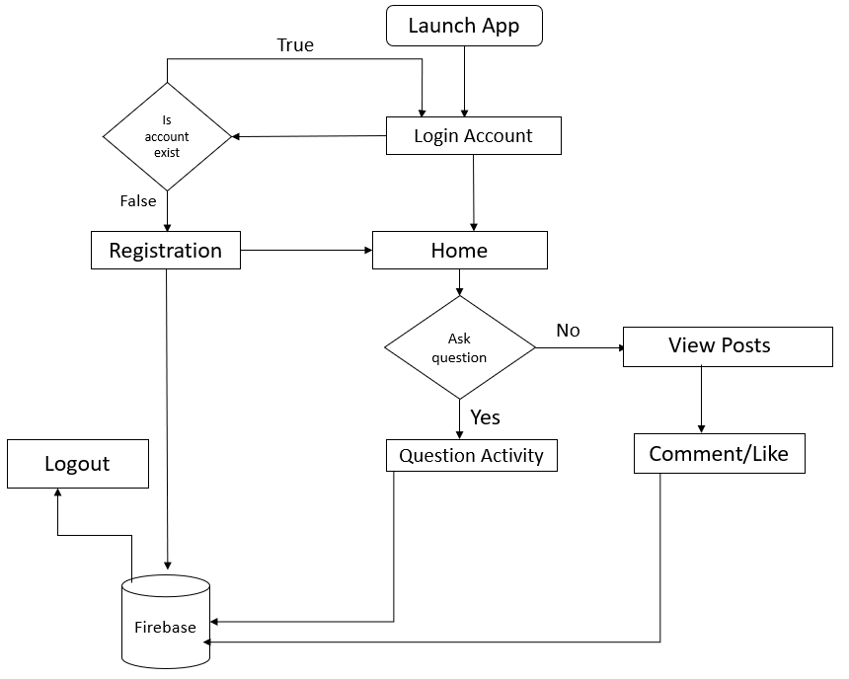

**Home:**

* The User can Register into the app and he goes to the Home page.
* User can add questions in the home page choosing the topic of his liking.

**User:**

* User logs in using their email ID into the app after signing up.
* User details displayed along with details in the nav bar.

**Comment:**

* A person who knows the answer can comment the answer here.

**Liking:**

* User can like or dislike the post of the question

**4.3 Database Design**

The database is designed using Google Firebase Console in which data is stored in popular data structure known as JSON tree (JavaScript Object Notation). Every time when the data transfer happens from client end, the information given to the UI is converted into JSON tree structure which is efficient and faster way to retrieve and store data.

**A snapshot of user Authentication:**

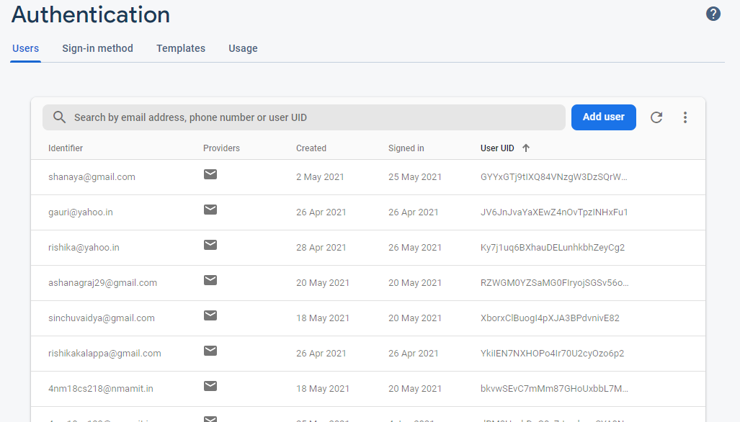

**A snapshot of data in the Firebase database:**

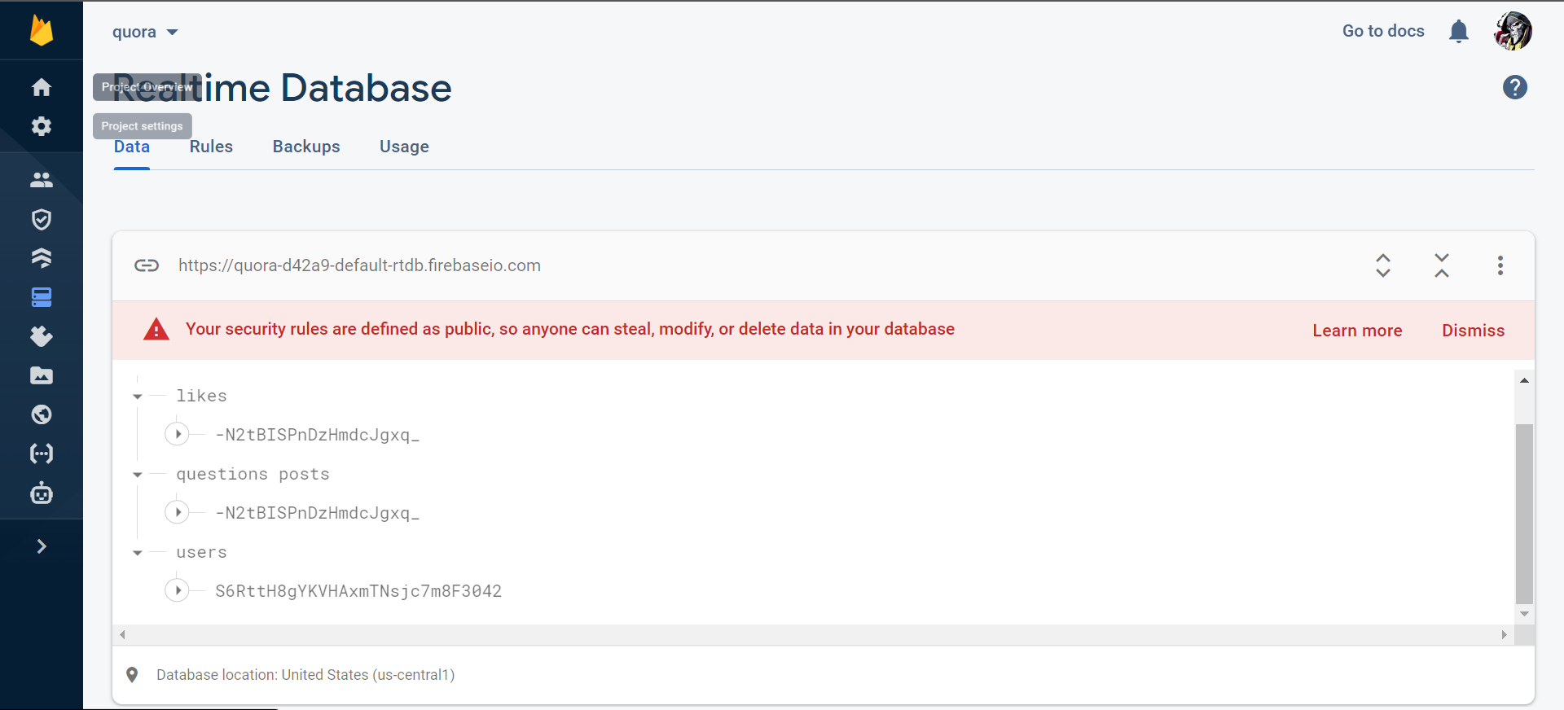

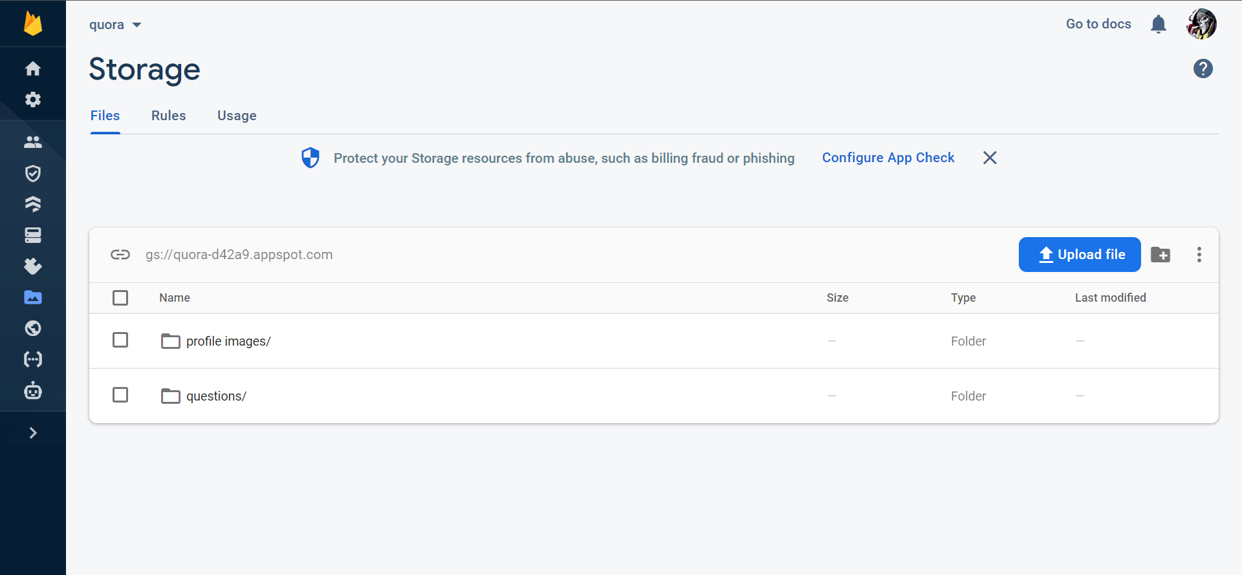

**CHAPTER 5**

**IMPLEMENTATION**

We are here enabling people to ask question and answer questions from different topics.

**5.1 SOLUTION APPROACH/METHODOLOGY**

We are here using xml and java for the front end and firebase for the backend as a server.

**5.1.1 FIREBASE**

Firebase is considered as web application platform. It helps query for inserting, updating, deleting or adding data to it. It is the backend of a system that is used as a database for storing data.

Firebase real-time database feature is very easy to use. Once the Firebase and database dependency is added to the app, unstructured data can be added to database.

**5.1.2 STORAGE**

The files like images, audio, video etc can be stored in the app. The data stored is highly secured and is robust in nature means it resumes from the last point if any network error occurs.

**5.1.3 FIREBASE AND ANDROID APP**

An Android application has been developed for the demonstration of Firebase. In this app images along with strings are loaded to Firebase and retrieved from Firebase similar to Instagram. For the development of an Android app to demonstrate the use of Firebase, prototyping model has been followed.

**Steps for connecting App to Firebase:**

Step1: An account in the Firebase Login has to be created at https://www.firebase.com/login/ using the Google account.

Step2: Creating a new application on Firebase. Firebase creates a new application when one logs in for the first time. Also, at the bottom left corner, one can find an option to create a new application on the Firebase server. The app URL has to be unique among all applications deployed on Firebase.

Step3: Next step is to add Firebase as a project dependency. Make changes to the following lines to the build.gradle file, which is located in the app’s project folder, and not the root folder. After adding any dependency, one has to make sure to sync the application. If there is any build error complaint about duplicate files then one can choose to exclude those files by adding the packaging Options directive to the build.gradle file: android

Step4: Next, add permissions to Android application, add network permission to the app, the same way it has been done for parse earlier. Now add the following line to the AndroidManifest.xml file:

<uses-permission android:name="android.permission.INTERNET" / >

Firebase is a Backend-as-a-Service — BaaS — that started as an YC11 start up and grew up into a next-generation app-development platform on Google Cloud Platform.

**5.1.4 Java**

There are several ways to create apps for Android devices, but the recommended method for most developers is to write native apps using Java and the Android SDK. Java for Android apps is both similar and quite different from other types of Java applications.

If you have experience with Java (or a similar language) then you’ll probably feel comfortable diving right into the code and learning how to use the Android SDK to make your app run. But if you’re new to programming or object-oriented languages then you’ll probably want to get familiar with the syntax of the Java language and how to accomplish basic programming tasks before learning how to use the Android SDK.

**5.2 IMPLEMENTATION CODE**

**Login:**

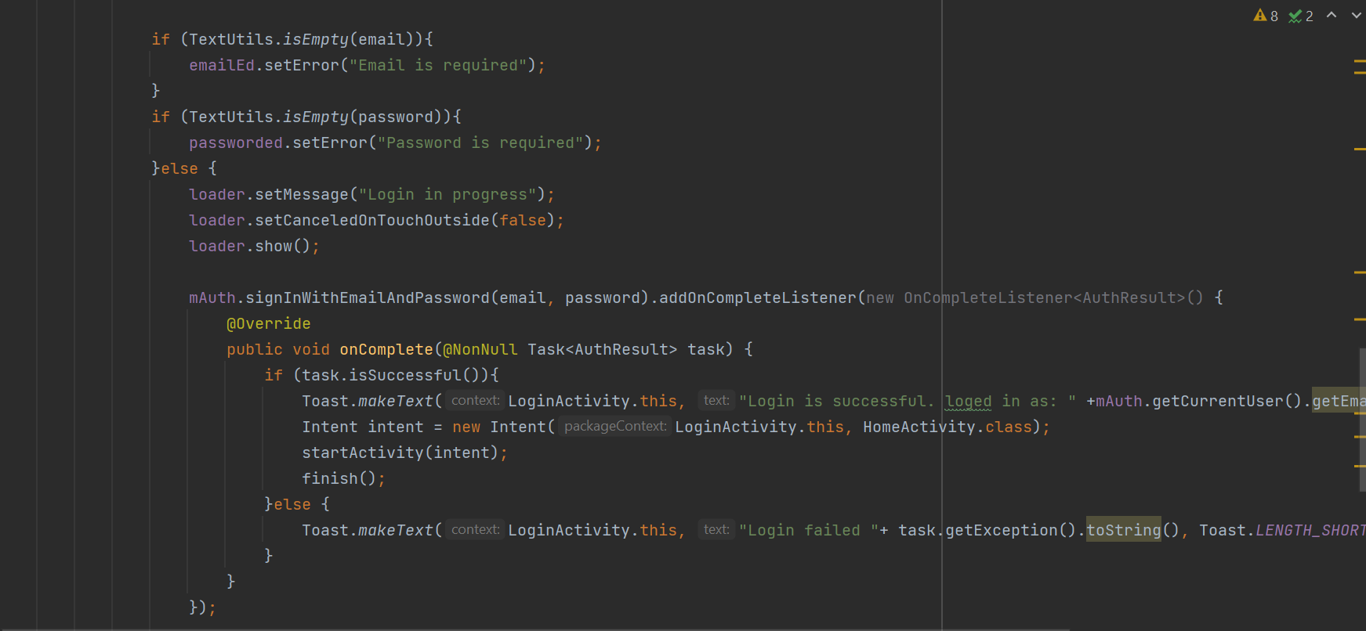

**Register:**

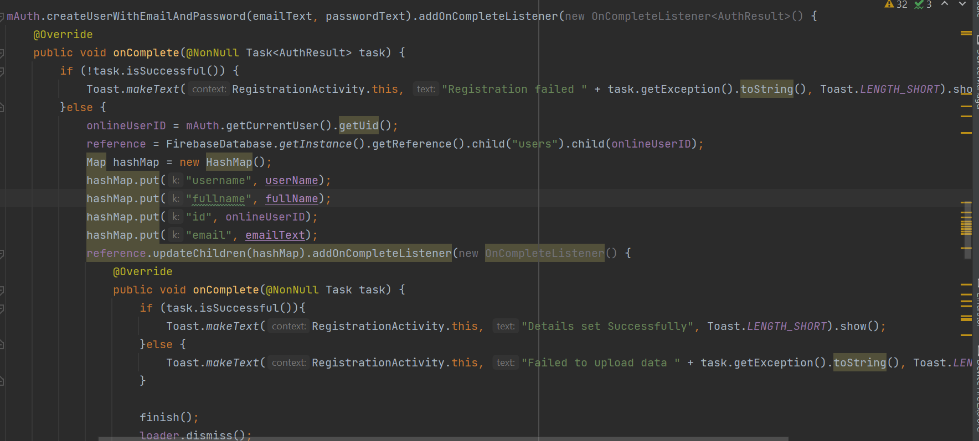

**Asking Questions:**

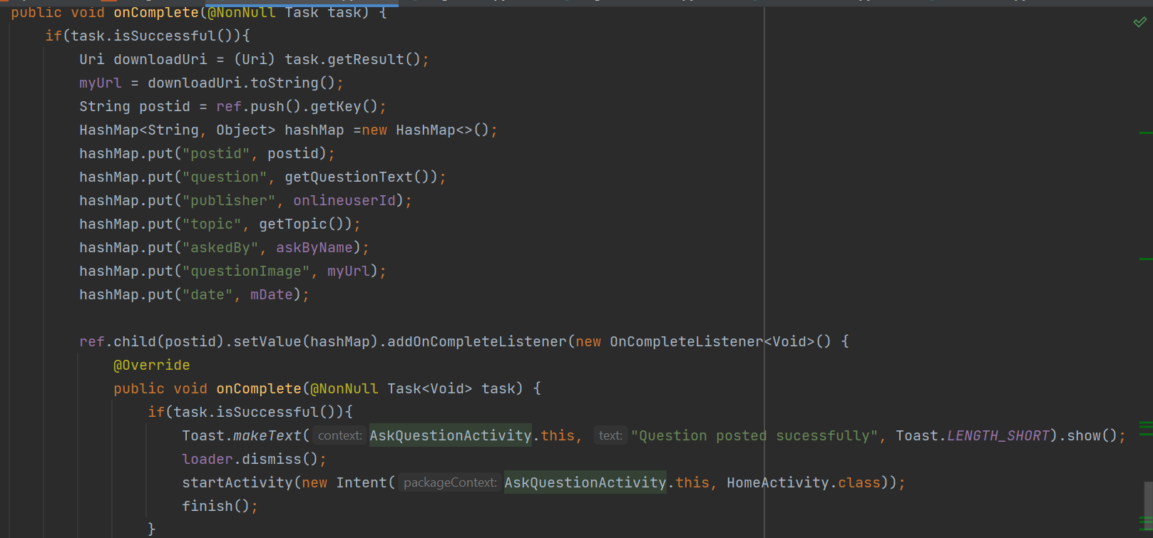

**Question post:**

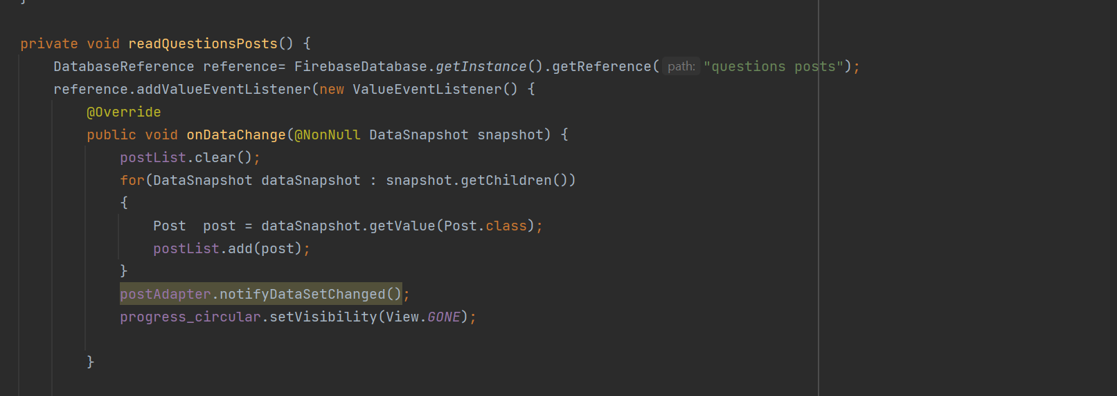

**Comment Answer:**

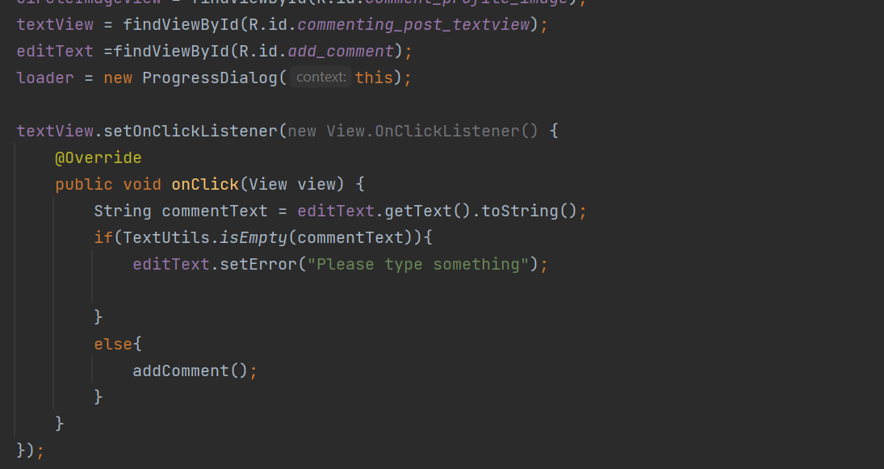

**CHAPTER 6**

**SCREENSHOTS**

**Log In Activity:**

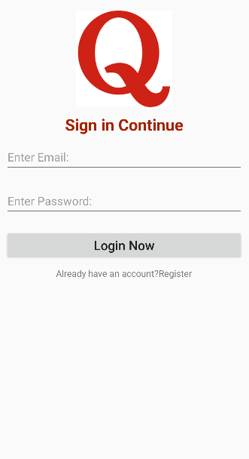

**Admin Registration Activity:**

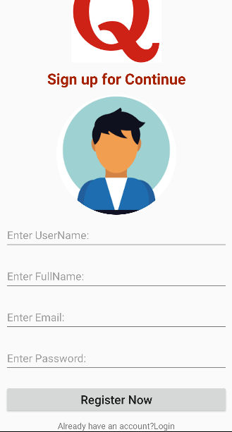

**Ask Question Activity:**

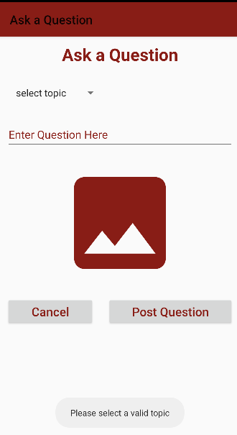

**Question View :**

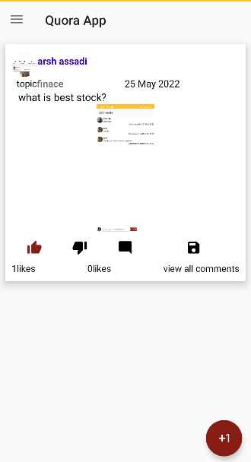

**Nav Bar View:**

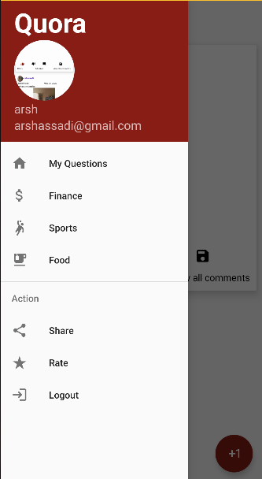

**Comment Activity:**

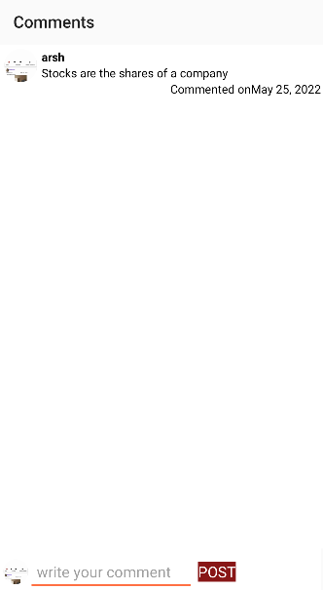

**CHAPTER 7**

**CONCLUSION AND FUTURE WORK**

**7.1 Results/Conclusion:**

* Quora clone app where you login and ask questions an choose the topic
* The User can post pictures related to the question.
* The User can comment the answers of the questions he has seen in the post.
* The User can like/ dislike the question asked .

**7.2 Future Works**

In the future, we may extend this project by adding extra features to our android app like,

* Updating the app for the user to be able to edit/ delete his post.
* More options for other users to report other’s post.
* Provision for users to be able to communicate with each other.
* Monetize the app such that user’s who asked good questions or have given good answers get money.

**8 References**

* “Overview Guides Reference Samples Libraries Support Go to console” Documentation Firebase, <https://firebase.google.com/docs/>
* Stack Overflow, [https://stackoverflow.com](https://stackoverflow.com/)
* YouTube, [https://www.youtube.com](https://www.youtube.com/)